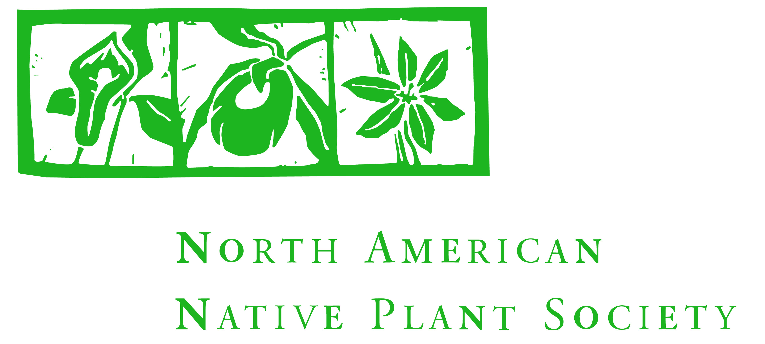

Agenda

NANPS AGM & Social and Ontario Nature Regional Meeting

Saturday October 27, 2018, 9:00 am to 3:30 pm
Toronto Botanical Garden, 777 Lawrence Ave. E, Toronto ON

9:00 – 9:35 NANPS Business Meeting
Welcome
Financial Report
Meet Your Board

9:35 - 10:00 Refreshment Break

10:00 - 11:30 Welcome Ontario Nature, Lake Ontario North region
Ontario Nature member group presentations

11:30 – 12:20 NANPS Awards Presentations
Volunteer Award
Founders Conservation Award
Richard Woolger Cultivation Award
Garden Award

12:20 – 1:00 Light Lunch

1:00 – 1:15 NANPS Year in Review

1:15 – 2:00 Ontario Nature: Board Update and Nature Network Update

2:00 – 2:30 Introduction to Alan Colley
Walk to hike start location

2:30 – 3:30 Hike with Alan Colley, Wilket Creek Park

